# Part 1: Using the Basic Classifier and Implementing Grad-CAM

## Does the AI explanation make sense:

I have minimal experience with Python and the AI explanation of the code made sense. Though some of it could be confusing with no experience with any programming language, I could ask it to explain it to me in more detail or like I have no programming experience. Those explanations were simpler and easier to understand, it felt like a person was explaining it to me rather than a smart computer.

## Record the top 3 predictions and their confidence scores:

1. Tabby (0.93)
2. Tiger Cat (0.03)
3. Egyptian Cat (0.0)

## Analyze the Heatmap:

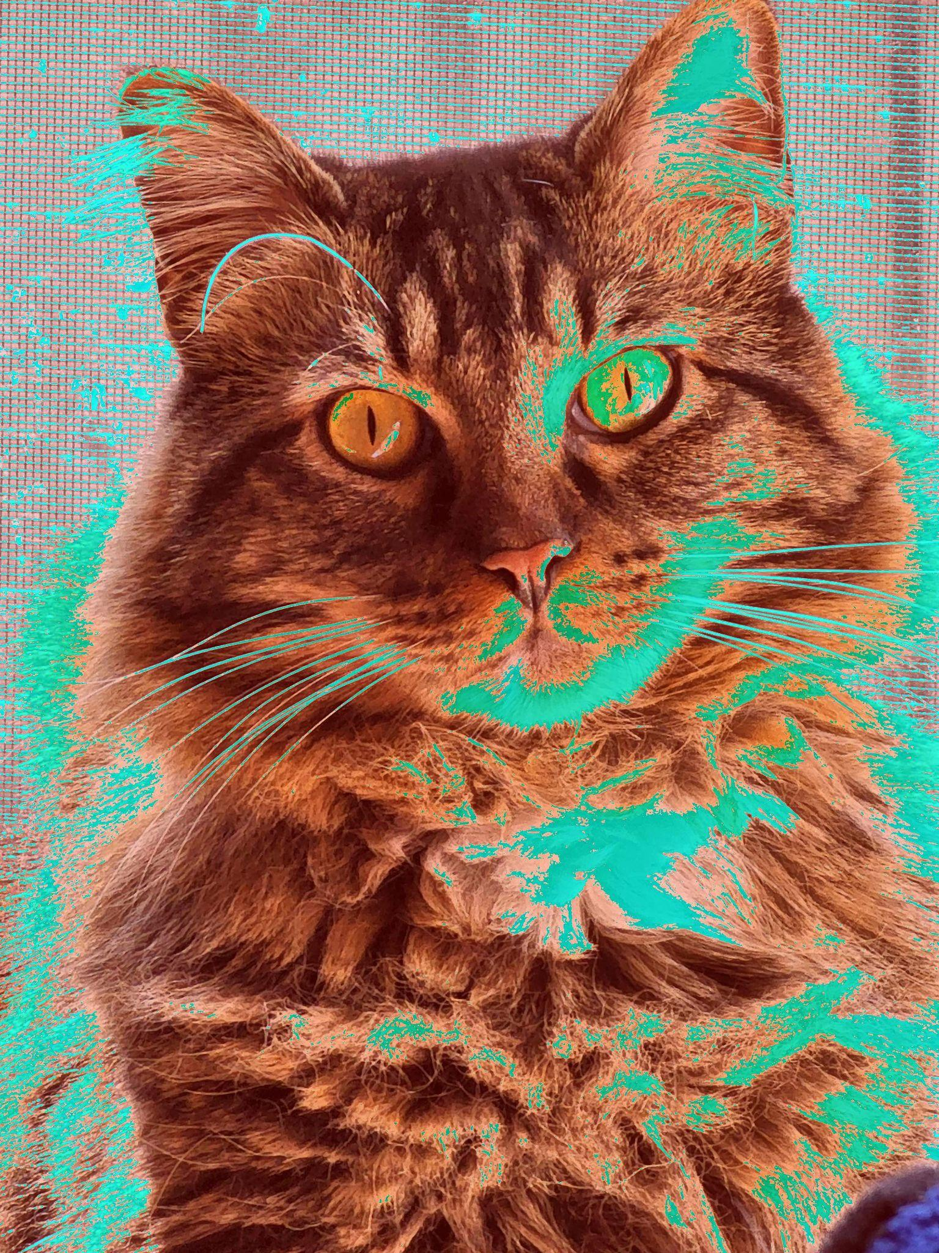

Identify which parts of the image the classifier focuses on most heavily:

It had the most focus on most of the cats like the eyes, parts of the face, and the ears. It has a medium focus on parts of the body like the fur and parts of the background.

# Part 2: Experimenting with Image Occlusion

## Generate Occlusion Ideas:

1. Add a black or colored box
2. Blurring parts of the image
3. Random pixel occlusion (noise masking)

## Test the Occlusions:

Record the top 3 predictions and confidence scores for each occlusion.

Black Box:

1. Tabby (0.92)
2. Tiger Cat (0.06)
3. Egyptian Cat (0.0)

Blurring:

1. Tabby (0.89)
2. Tiger Cat (0.09)
3. Egyptian Cat (0.01)

Noise Masking:

1. Tabby (0.88)
2. Tiger Cat (0.07)
3. Egyptian Cat (0.01)

## Analyze the Results:

Compare the classifier's performance on the original image vs. the occluded versions.

Answer the following questions:

* Did the classifier struggle to classify the occluded images?
  + Not really, they all had similar scores with Tabby being first in each one.
* Which occlusion had the greatest impact on performance?
  + Noise Masking was the most different from the original picture.

# Part 3: Creating and Experimenting with Image Filters

## Does the AI explanation make sense:

The AI explanation of this program makes sense. Since this program was pretty simple I had an idea of how it would work before the explanation. It did agree with my interpretation of the program.

## Explore Filter Ideas:

1. Sharpen

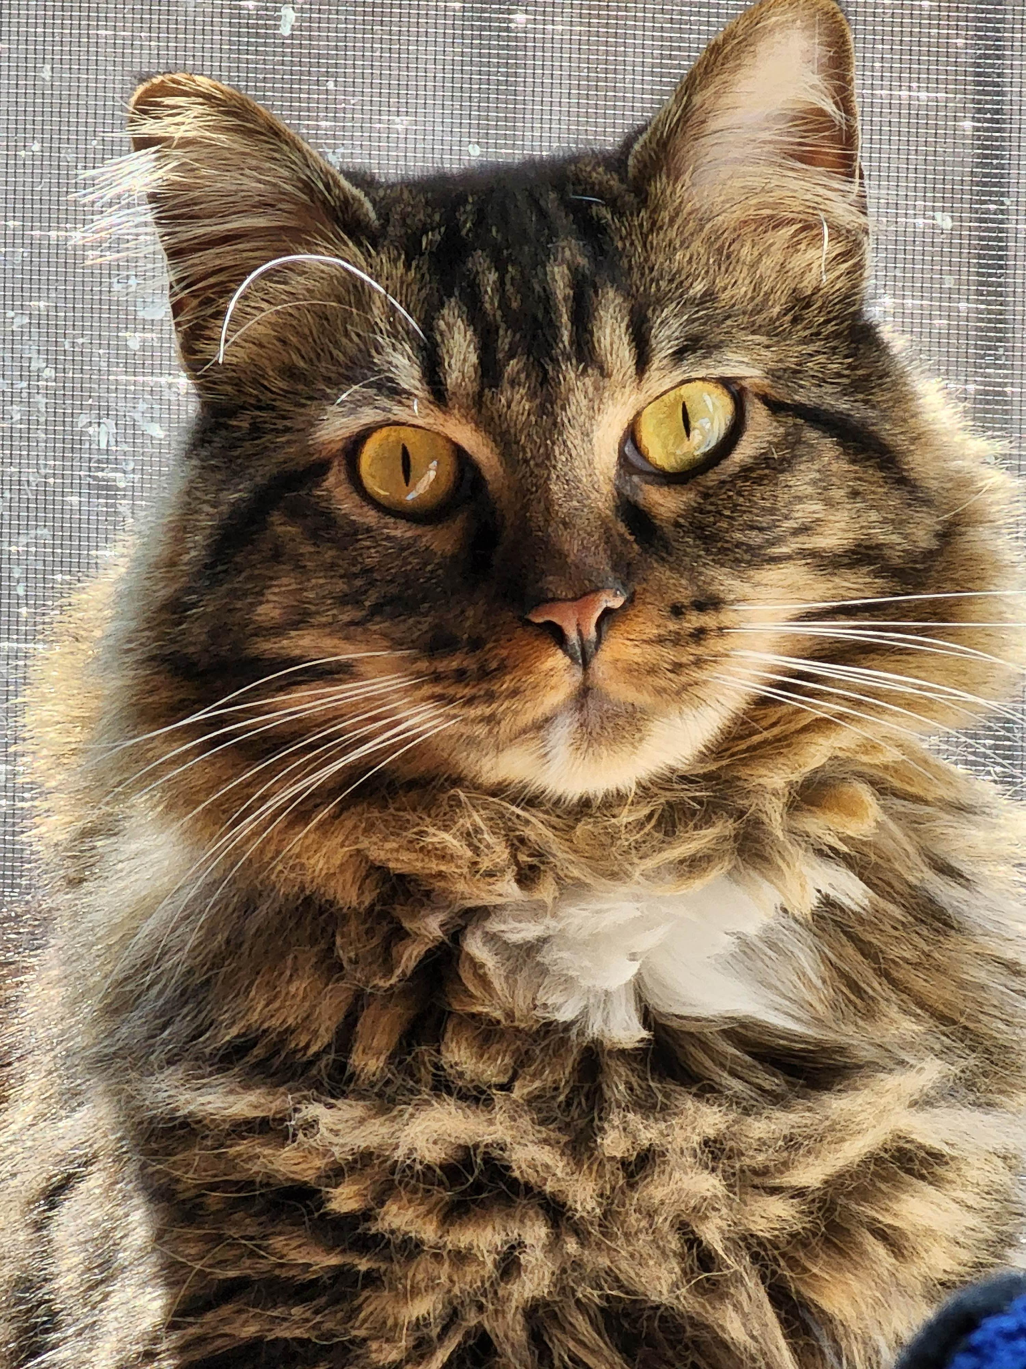

1. Edge Detection

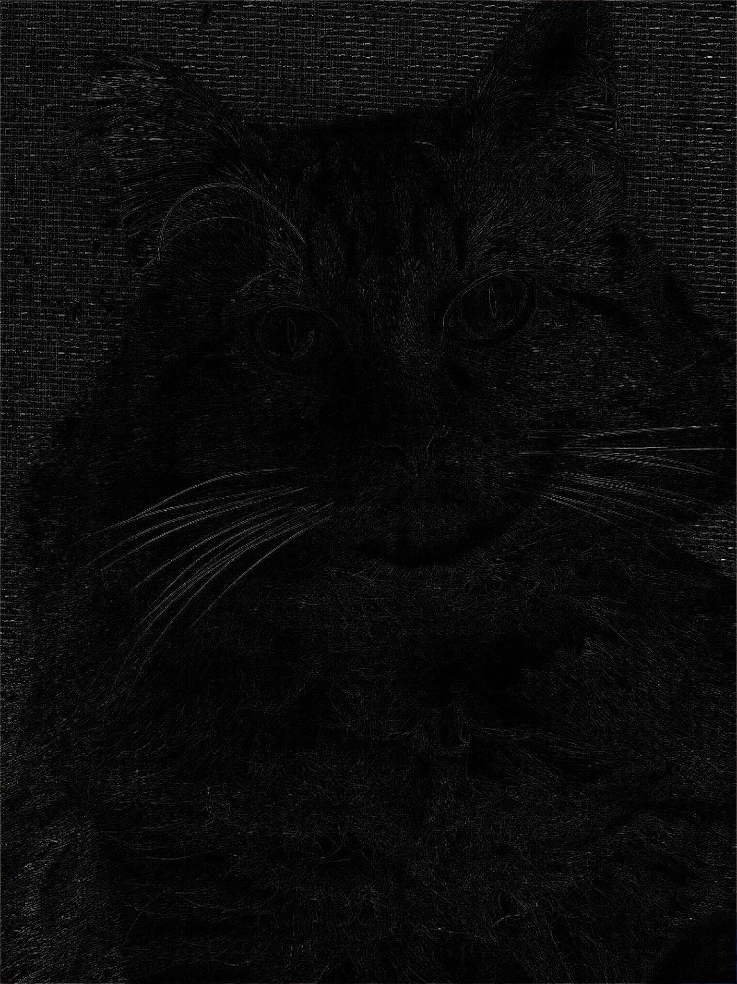

1. Contour

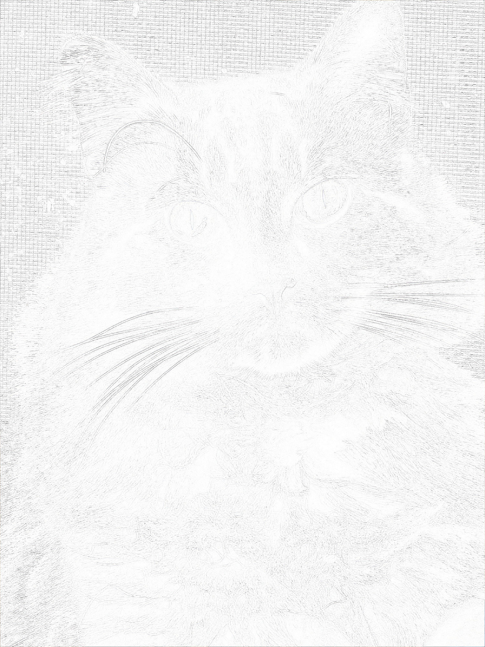

## Final Report:

Describe the filter you developed. What kind of effect does it have on your image?

Reflect on your experience working with the AI to explain and write Python code.

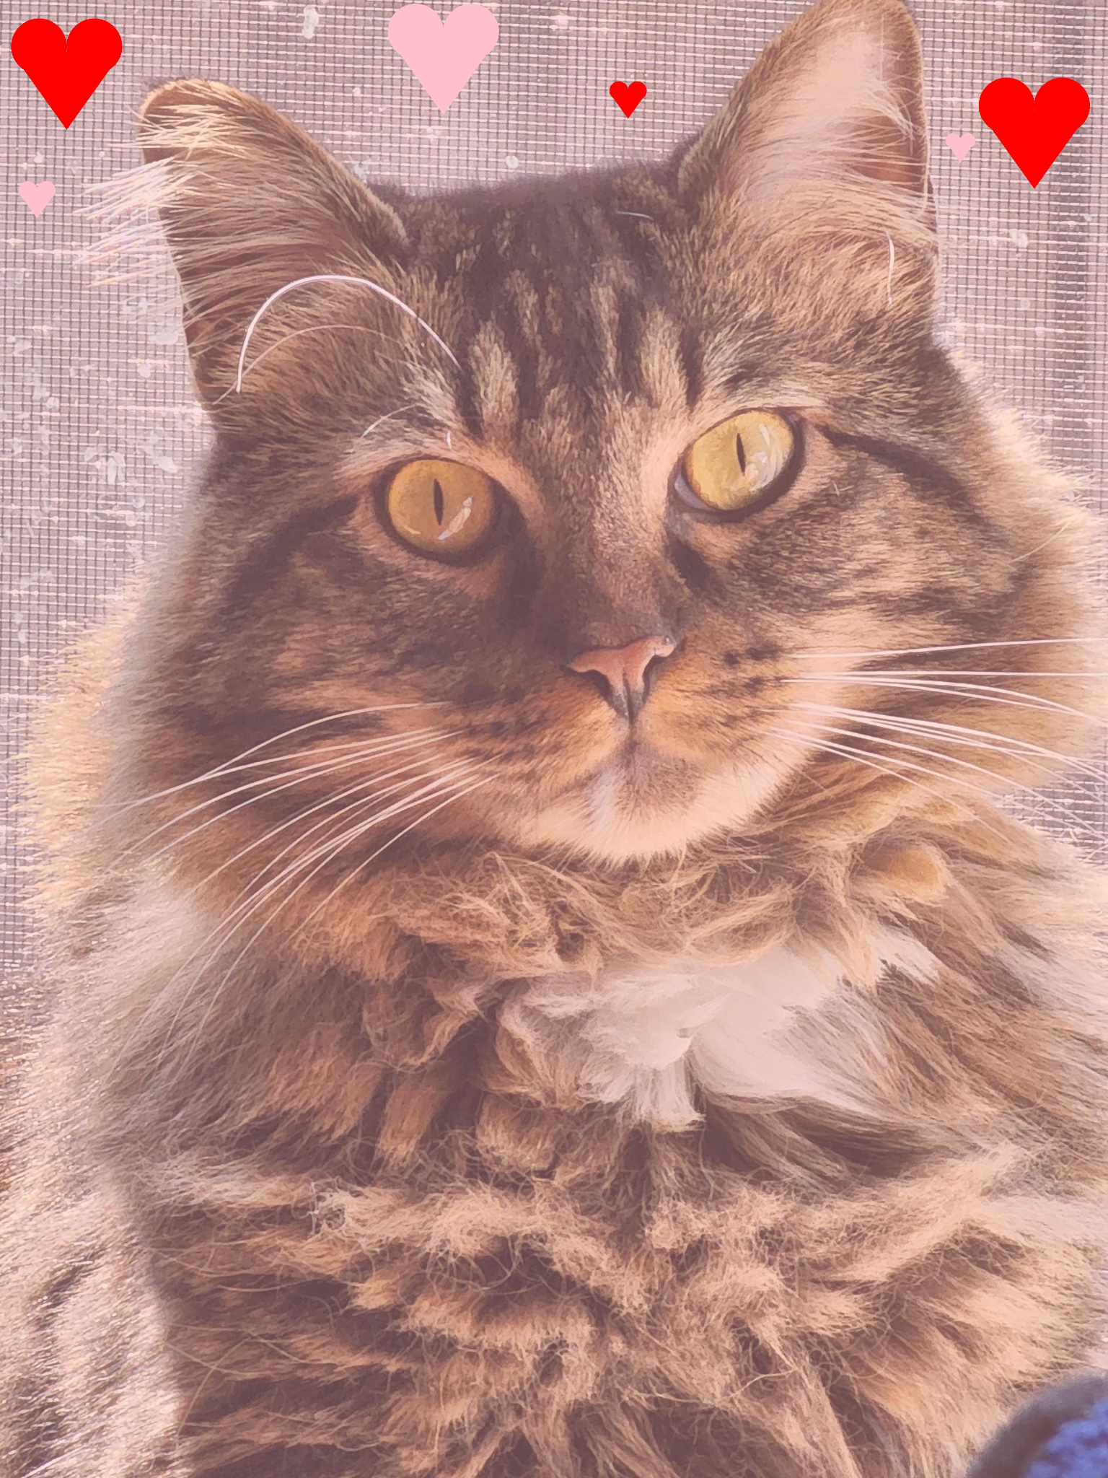

I wanted to make a Valentine's filter for my cat. Add a pink tint to the picture and hearts around him. I thought it would be cute, and I was right. It was pretty simple working with the AI to write the code. I described what I wanted to be done in the filter in detail and asked AI to fix any issues from there. I struggled to get the hearts to turn out right because the AI kept telling me to change the size instead of the location of the triangle that makes up the heart. Once I just ignored the AI and messed around with the numbers I was able to figure it out. The AI helped set a base but I still had to go in and refine it to get it how I wanted it.